**List, Tuples, Strings, Classes, and Inheritance**

**ITM205: Object Oriented Programming**

**Professor: Dr. Santos Galvez**

**By Odiscious Dozier**

**Trident University**

**SLP 04 – Exercises**

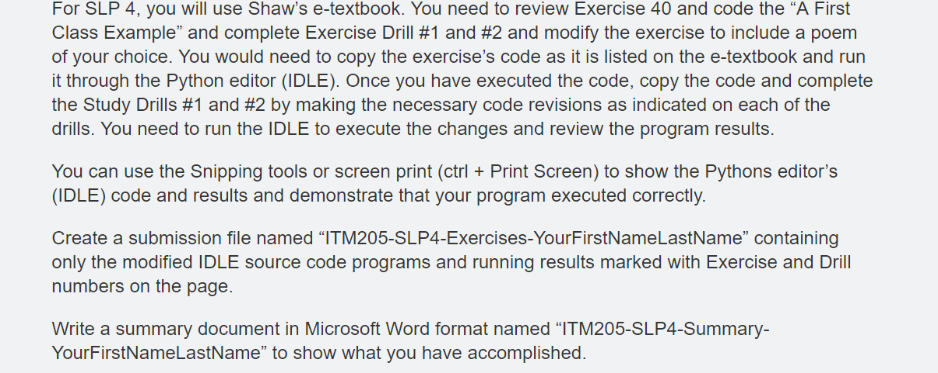

A First Class Example

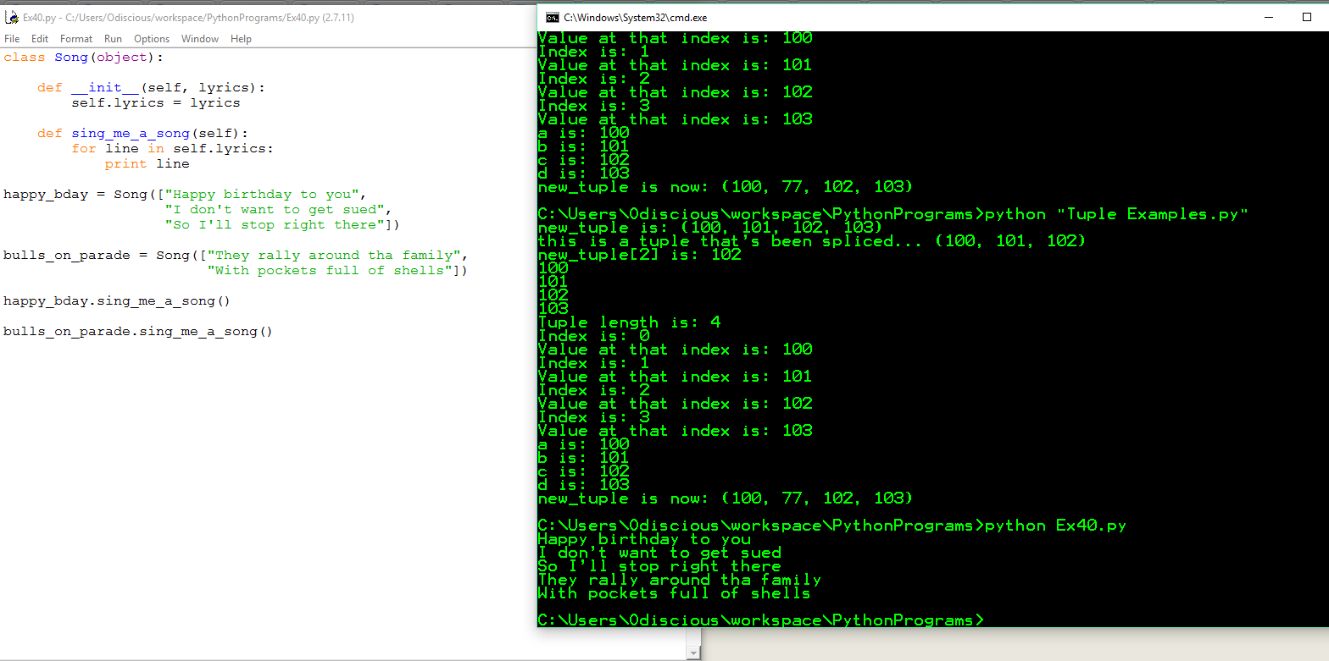

**Write some more songs using this and make sure you understand that you're passing a list of strings as the lyrics.** 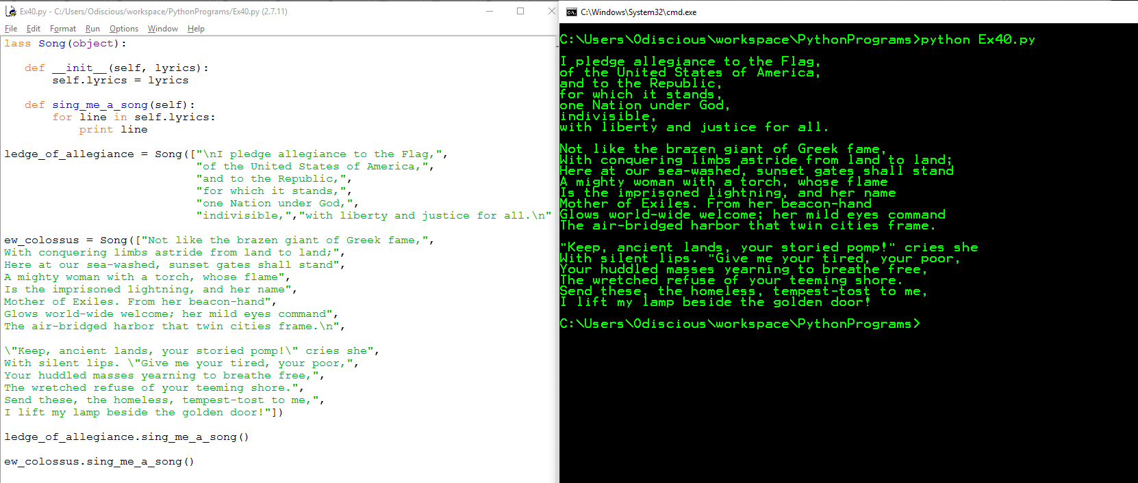

**Put the lyrics in a separate variable, then pass that variable to the class to use instead.**

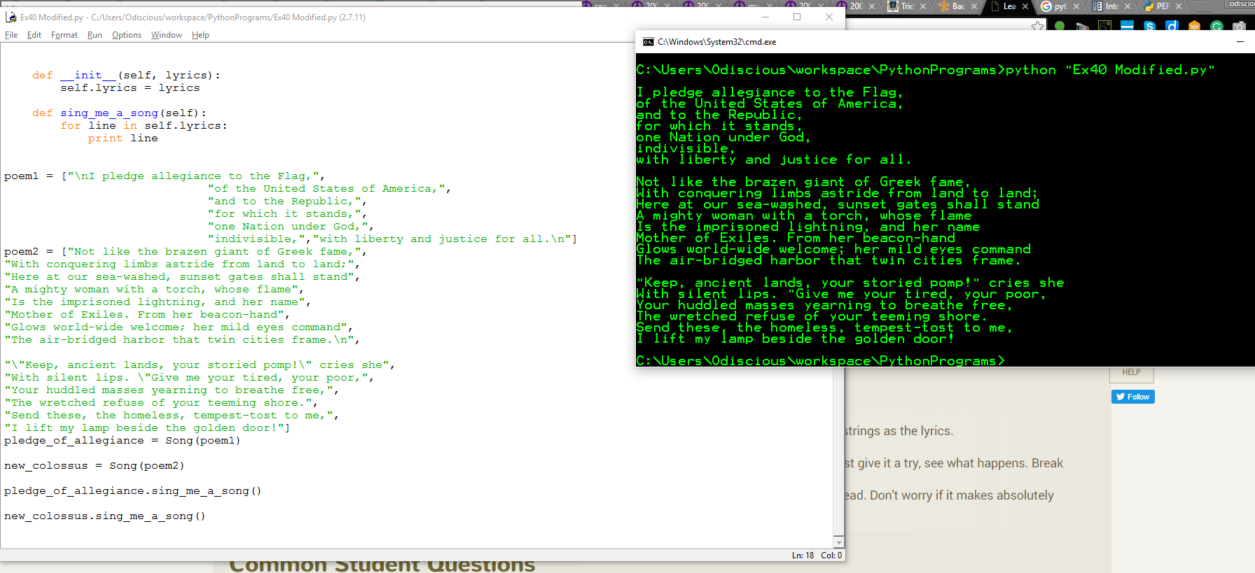

Exploring public, private variables

